W07 Assignment: Team Project
Project Status Meeting Summary
Link project : https://github.com/users/diogorangel/projects/5
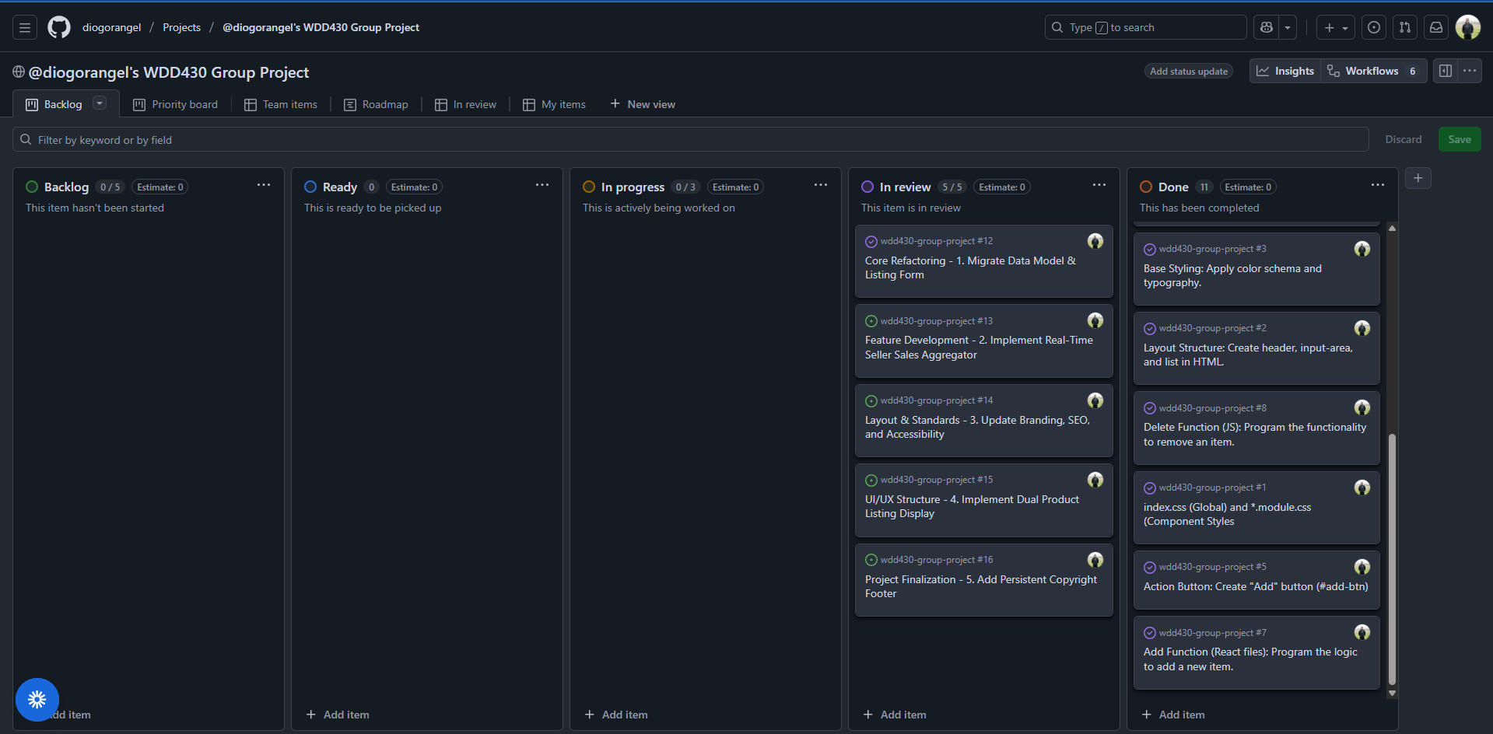
Link Repository : https://github.com/diogorangel/WDD430-Group-Project.git
Live project : https://wdd430-group-project-sigma.vercel.app/
Link of presentation video : https://www.loom.com/share/bf3877ca66a64274b0ad0fa29c8b0d48
Key Outcomes & Analysis
Success: Core Feature Development & Project Structure Implementation
The team has successfully implemented several foundational and core feature components necessary for the marketplace application, as evidenced by the modifications across the Next.js components:
- Input Component Development (Marketplace Form):
  - The single text input field (#new-task-input) was replaced by a comprehensive Product Listing Form in page.tsx. This form includes a new Product Title Input (id="new-listing-input") and a Seller Selection Dropdown (id="seller-select"), establishing the mechanism for artisans to list new products.
- List Display Implementation:
  - The necessary display element (<ul> with ID #task-list) was refactored into two distinct list views in page.tsx: the Curated Collection (id="featured-listings") and the All Listings (id="all-listings"), which supports product browsing and curation.
- Feature Component Extension & Logic:
  - The state logic for task completion (isComplete) was repurposed to Curated Status (isFeatured).
  - Crucially, a Seller Sales Summary feature was implemented using the useMemo hook in page.tsx. This component calculates and displays the total sales sum per artisan, addressing the request to sum all products sold by the seller when a new listing is added.

Development Progress: Styling, Responsiveness, and Data Persistence
The project has established foundational elements in place for branding, web standards, and data handling:
- Branding & SEO: The application metadata (title and description) in layout.tsx was updated to reflect the Handcrafted Haven brand and purpose. Base styling and color schemes were adjusted in globals.css to align with a marketplace aesthetic.
- Accessibility (WCAG 2.1 Level AA): aria-label attributes were strategically added/updated on all interactive elements (inputs, buttons, select) to ensure compliance with accessibility standards.
- Layout Implementation: A persistent Footer component with the required copyright information was added to the layout.tsx file, ensuring its presence across all pages.
- Data Persistence (Simple): Data saving to Local Storage (useLocalStorage hook) was retained, ensuring product listings persist between user sessions.

In summary:
Development Progress: Data Persistence via Local Storage was retained. Branding and SEO were applied via updated metadata and styling. Core UI components, the Product Listing Form (Product Title Input and Seller Selection Dropdown) and the Dual List Display (Curated/All Listings), were created. The Seller Sales Summary feature was implemented to display total revenue per artisan.

